# UART Problem with multiple drivers

When connection multiple drivers you are able to read/write commands to the drivers individually using the same bidirectional line.

Strangely enough I could not figure out why the above configuration did not work.

These are the configurations I tested with:

|  |  |  |  |  |
| --- | --- | --- | --- | --- |
|  | PDN UART | TMC software address settings | Result | Additional notes |
| TMC driver A | Connected to RX | 1 | Functional | Changing one address to 0 also makes it NOT functional |
| TMC driver B | Floating | 1 |  |  |
|  |  |  |  |  |
| TMC driver A | Floating | 0 | Functional |  |
| TMC driver B | Connected to RX | 0 |  |  |
|  |  |  |  |  |
| TMC driver A | Connected to RX | 0 | NOT Functional |  |
| TMC driver B | Floating | 1 |  |  |
|  |  |  |  |  |
| TMC driver A | Floating | 0 | NOT Functional |  |
| TMC driver B | Connected to RX | 1 |  |  |

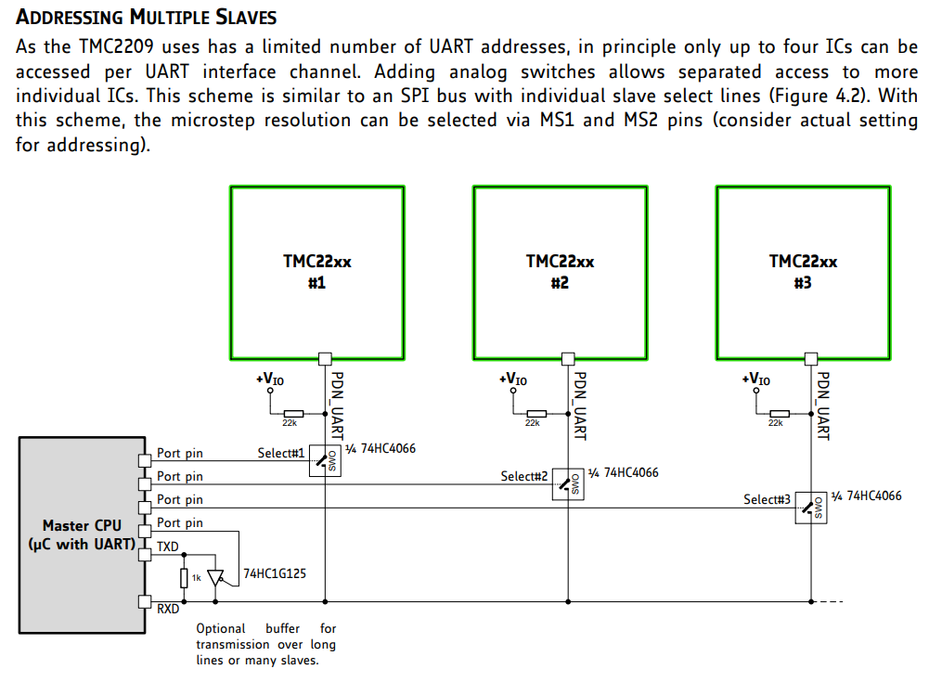First Conclusion/solution

The driver UART control only works if there is one driver connected to RX and assigned address to this driver is selected in software (according to the ms1 + ms2 settings you chose). You can however use 2 drivers if you go with the “more than 4 drivers solution” which Trinamic provided. This could be achieved with transistors as well I suppose.

If reading from the driver is not required, using the write only function as seen in figure 4.1 of the datasheet is a viable option. This way we only need to use n+1 pins of the raspberry pi to control the motors, where n increases with every driver added (enable pin). This would treat all steppers as the same and would control them using the enable pin and sending data over the RX pin.

# Further testing UART communication TMC2209

Configuration (test script 05: vactual.py) **RX and TX are flipped** **in the pictures:**

This is what a successful transmission, with a few rotations and direction changes should look like.

When zoomed in it is clear that the TX deviates from the RX line data.

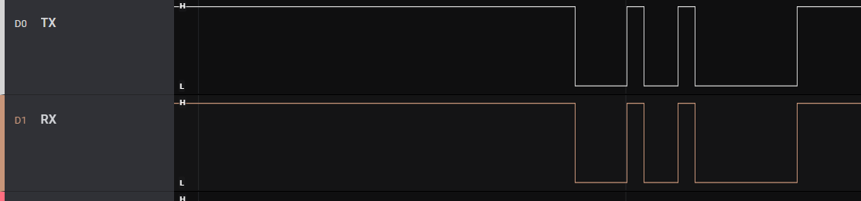Further inspection shows that it does sometimes match the RX line

It is however always the case that TX continues sending after RX is done with a package.

It is however always the case that TX continues sending after RX is done with a package.

Using these settings (test script 06: multiple drivers.py) **RX and TX are flipped** **in the picture:**

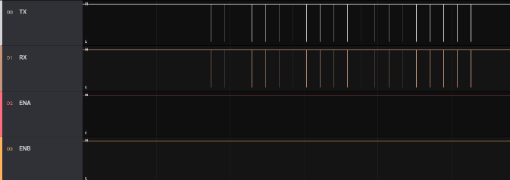

This is what a unsuccessful transmission looks like:

When zoomed in it seems that TX receives exactly the same information as it sends out. While, as stated earlier, it is expected that TX sends more data after RX is finished.

### 

### Final conclusion and solution for the UART error

I can conclude that somehow TX is getting the same information as it sends out on the RX line.

With the help of Thomas Ijsseldijk we found the cause and the fix for this problem. Lowering the TX resistor to 500ohms (from 1k) increases the voltage available for the IO of the TMC driver which results in the TMC being able to read the signal. It appears to be very important to choose the right resistor value. It is now possible to control the stepper motors via UART. This reduces the pins required on the raspberry pi with 7 pins (removing all step and dir pins)

The final configuration for the stepper motor drivers is as following:

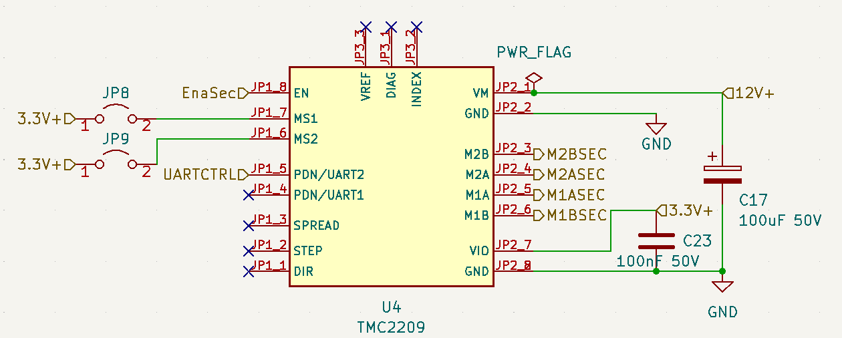

We decided to go with the TMC2209 and we operate it in UART mode only. This means we need to connect to PDN UART and use one enable pin per driver to select it. The jumpers are there to select the driver address (up to 4 drivers in total).